2021/2022 UConn RISE Competition Application
(Real Impact on Society & Environment)

PROJECT TITLE: Click or tap here to enter text.
PROJECT LOCATION: Click or tap here to enter text. DATES (IF APPLICABLE): Click or tap here to enter text.
TEAM MEMBERS
Projects may be individual or group led. Where there has been a large student group participating, a leadership group of up to seven (7) students should be identified as the main entrants.
 | Name | College/School | Degree | Expected  Graduation | Add * for  Primary  Contact
e.g. | Jonathan Husky | School of Engineering | M.Eng Civil & Environmental Engineering | 05/2022
1. | Click or tap here to enter text. | Click or tap here to enter text. | Click or tap here to enter text. | Click or tap here to enter text. | Click or tap here to enter text.
2. | Click or tap here to enter text. | Click or tap here to enter text. | Click or tap here to enter text. | Click or tap here to enter text. | Click or tap here to enter text.
3. | Click or tap here to enter text. | Click or tap here to enter text. | Click or tap here to enter text. | Click or tap here to enter text. | Click or tap here to enter text.
4. | Click or tap here to enter text. | Click or tap here to enter text. | Click or tap here to enter text. | Click or tap here to enter text. | Click or tap here to enter text.
5. | Click or tap here to enter text. | Click or tap here to enter text. | Click or tap here to enter text. | Click or tap here to enter text. | Click or tap here to enter text.
6. | Click or tap here to enter text. | Click or tap here to enter text. | Click or tap here to enter text. | Click or tap here to enter text. | Click or tap here to enter text.
7. | Click or tap here to enter text. | Click or tap here to enter text. | Click or tap here to enter text. | Click or tap here to enter text. | Click or tap here to enter text.

PROJECT DESCRIPTION
Identify the UN Sustainable Development Goals (SDGs) that your project addresses and how this is a new approach to addressing the problem. Have there been previous attempts, why have they not worked or had limited success? Explain exactly what your project will do and how/why it will be successful (700 word limit)
Click or tap here to enter text.

PROJECT STAGE
Identify what stage you are in for this project. Note that entries must be past the idea stage. (300 word limit)
Click or tap here to enter text.

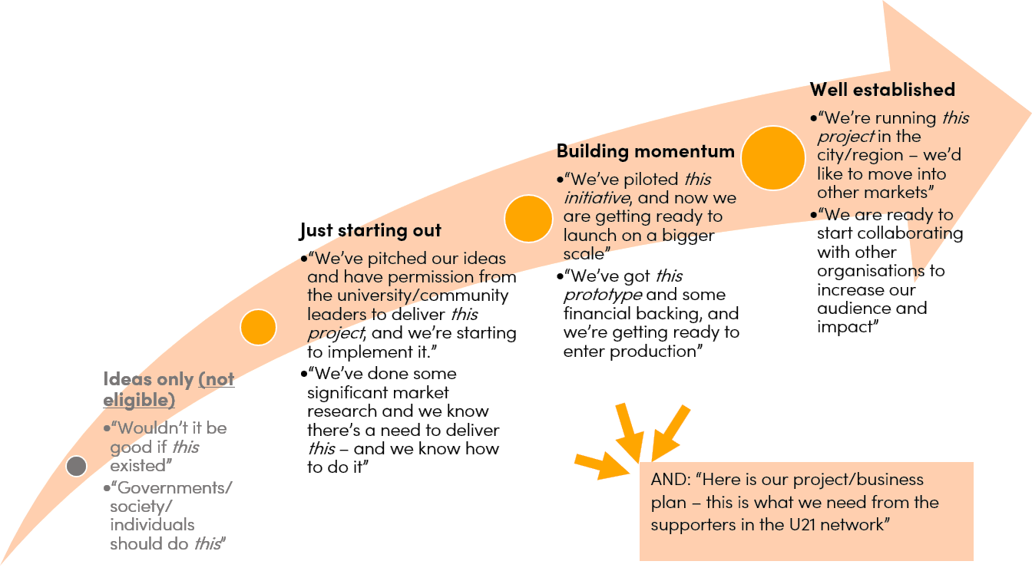

THEORY OF CHANGE
A Theory of Change helps map your path to achieving your goals from problem statement to long-term change. It helps define the problem and determine if the activities you propose will have the impact you envision. List key assumptions for each stage.
Problem | Resources/  Inputs | Interventions/  Activities | Outputs | Outcome | Impact
What is the problem you are trying to solve?  Click or tap here to enter text. | What resources are needed to operate your program?  Click or tap here to enter text. | What steps and activities are needed to bring about change?  Click or tap here to enter text. | If you accomplish your planned activities, then what will the measurable effects be?  Click or tap here to enter text. | If you accomplish your planned activities, then how will your participants benefit?  Click or tap here to enter text. | If the benefits to participants are achieved, then what long-term change in communities, systems, and organizations are expected?  Click or tap here to enter text.
Assumptions  Click or tap here to enter text. | Assumptions  Click or tap here to enter text. | Assumptions  Click or tap here to enter text. | Assumptions  Click or tap here to enter text. | Assumptions  Click or tap here to enter text. | Assumptions  Click or tap here to enter text.

PROJECT TIMELINE
Insert a timeline with key deliverables and assessment periods.
Click or tap here to enter text.
MARKET ANALYSIS AND NEEDS ASSESSMENT
Identify and engage the stakeholders to ensure there is a need and support for the proposed interventions. Explain the current situation, stakeholder needs, how this was determined and why the proposed project will help satisfy those needs. (700 word limit)
Click or tap here to enter text.
MARKETING PLAN
What is your marketing plan? Who is your target market? You should mention the people you want to benefit from your project and the strategies you want to use to reach out to them. Are you going to use flier, posters, the Internet, or targeted personal contact, etc.? What about a secondary marketing plan that will target donors/funders? Will it differ? (700 word limit)
Click or tap here to enter text.
PARTERS & ORGANIZATIONAL STRUCTURE
Insert an organizational chart for what your “team” will look like with a brief explanation of who will be the people/groups to help you carry out your project? Who are your potential partners? Finally, what is your strategy to get them on board? (300 word limit)
Click or tap here to enter text.

FINANCIAL NARRATIVE & BUDGET
How much start-up capital do you need? What sources are available to provide seed capital? How will you spend it? What is your burn rate? How will you acquire capital to go to the next level? How will you fund scaling the project, if you plan to do so? (300 word limit for narrative; attach excel file for budget)
Click or tap here to enter text.
MONITORING & EVALUATION PLAN
Monitoring and evaluation should happen throughout the lifecycle of the project. Monitoring is the regular collection of information about all project activities and key indicators that are set forth before the project begins. Evaluation helps identify if the project is achieving what it set out to do. If the project is falling short of objectives this process allows for questions to be raised as to how you can alter the project activities to meet the objectives, or perhaps alter the objectives to meet changing needs. How will you measure success? What are your measurement data points? What is the desired impact of your project in your community? Are there any environmental costs/benefits? How will you prove that your theory of change works? (700 word limit)
Click or tap here to enter text.
APPLICATION SUBMISSION GUIDELINES
Save this document wilt the file name as “Last(Family)Name.First(Given)Name – 2021 U21 RISE Application”. If you are submitting the application as a part of a team, use the name of the primary contact for the team when saving the file. Upload the file to https://globalpartnerships.uconn.edu/universitas-21/u21-rise-showcase-and-awards/ along with the excel file for the budget, and the 3-5 minute pitch video.
VIDEO PITCH
Upload a 3-5 minute pitch video. Be creative with your presentation, but make sure you communicate the items listed in this application. Resources:
Information Technology Services Academic IT
Audio Visual Technology Support: https://ait.uconn.edu/avt-support
Lightboard: https://ait.uconn.edu/lightboard/

